# C++ Pointers and Arrays

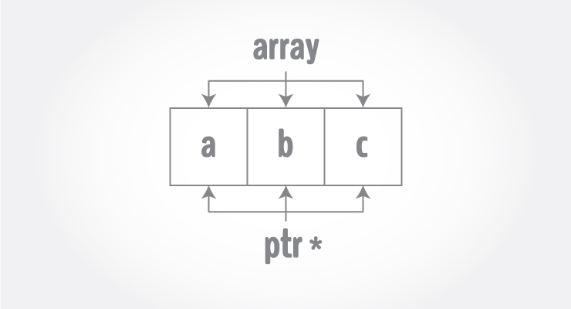

Pointers are the variables that hold address. Not only can pointers store address of a single variable, it can also store address of cells of an array.

Consider this example:

int* ptr;

int a[5];

ptr = &a[2]; // &a[2] is the address of third element of a[5].

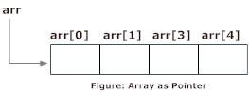

Suppose, pointer needs to point to the fourth element of an array, that is, hold address of fourth array element in above case.

Since ptr points to the third element in the above example, ptr + 1 will point to the fourth element.

You may think, ptr + 1 gives you the address of next byte to the ptr. But it's not correct.

This is because pointer ptr is a pointer to an int and size of int is fixed for a operating system (size of int is 4 byte of 64-bit operating system). Hence, the address between ptrand ptr + 1 differs by 4 bytes.

If pointer ptr was pointer to char then, the address between ptr and ptr + 1 would have differed by 1 byte since size of a character is 1 byte.

## Example 1: C++ Pointers and Arrays

**C++ Program to display address of elements of an array using both array and pointers**

#include <iostream>

using namespace std;

int main()

{

float arr[5];

float *ptr;

cout << "Displaying address using arrays: " << endl;

for (int i = 0; i < 5; ++i)

{

cout << "&arr[" << i << "] = " << &arr[i] << endl;

}

// ptr = &arr[0]

ptr = arr;

cout<<"\nDisplaying address using pointers: "<< endl;

for (int i = 0; i < 5; ++i)

{

cout << "ptr + " << i << " = "<< ptr + i << endl;

}

return 0;

}

**Output**

Displaying address using arrays:

&arr[0] = 0x7fff5fbff880

&arr[1] = 0x7fff5fbff884

&arr[2] = 0x7fff5fbff888

&arr[3] = 0x7fff5fbff88c

&arr[4] = 0x7fff5fbff890

Displaying address using pointers:

ptr + 0 = 0x7fff5fbff880

ptr + 1 = 0x7fff5fbff884

ptr + 2 = 0x7fff5fbff888

ptr + 3 = 0x7fff5fbff88c

ptr + 4 = 0x7fff5fbff890

In the above program, a different pointer ptr is used for displaying the address of array elements arr.

But, array elements can be accessed using pointer notation by using same array name arr. For example:

int arr[3];

&arr[0] is equivalent to arr

&arr[1] is equivalent to arr + 1

&arr[2] is equivalen to arr + 2

## Example 2: Pointer and Arrays

**C++ Program to display address of array elements using pointer notation.**

#include <iostream>

using namespace std;

int main() {

float arr[5];

cout<<"Displaying address using pointers notation: "<< endl;

for (int i = 0; i < 5; ++i) {

cout << arr + i <<endl;

}

return 0;

}

**Output**

Displaying address using pointers notation:

0x7fff5fbff8a0

0x7fff5fbff8a4

0x7fff5fbff8a8

0x7fff5fbff8ac

0x7fff5fbff8b0

You know that, pointer ptr holds the address and expression *ptr gives the value stored in the address.

Similarly, you can get the value stored in the pointer ptr + 1 using *(ptr + 1).

Consider this code below:

int ptr[5] = {3, 4, 5, 5, 3};

* &ptr[0] is equal to ptr and *ptr is equal to ptr[0]
* &ptr[1] is equal to ptr + 1 and *(ptr + 1) is equal to ptr[1]
* &ptr[2] is equal to ptr + 2 and *(ptr + 2) is equal to ptr[2]
* &ptr[i] is equal to ptr + i and *(ptr + i) is equal to ptr[i]

## Example 3: C++ Pointer and Array

**C++ Program to insert and display data entered by using pointer notation.**

#include <iostream>

using namespace std;

int main() {

float arr[5];

// Inserting data using pointer notation

cout << "Enter 5 numbers: ";

for (int i = 0; i < 5; ++i) {

cin >> *(arr + i) ;

}

// Displaying data using pointer notation

cout << "Displaying data: " << endl;

for (int i = 0; i < 5; ++i) {

cout << *(arr + i) << endl ;

}

return 0;

}

**Output**

Enter 5 numbers: 2.5

3.5

4.5

5

2

Displaying data:

2.5

3.5

4.5

5

2